

WEB SCRIPTING

CSE – 220 QUARTER V



September 28, 2020

M.Sathishkumar

E0119052

**Challenge 1:**

Create a function template literal with one parameter “num”.function is expected to return template literal.

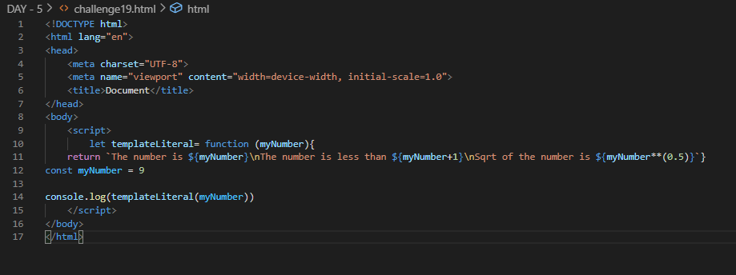

Output:

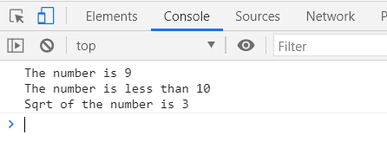

**Challenge 2:**

Create a TaggedTemplate function to satisfy ‘Sum of two variables a() and b() is {a+b}

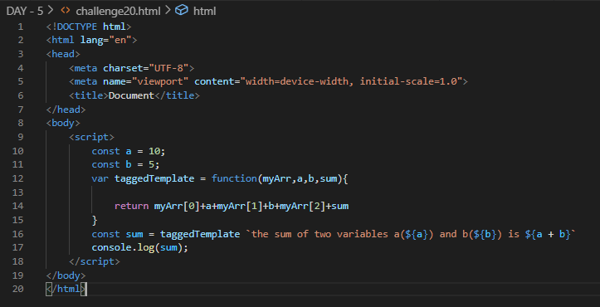

Output:

